SIT315

Dr shanky kansal

Screenshot:

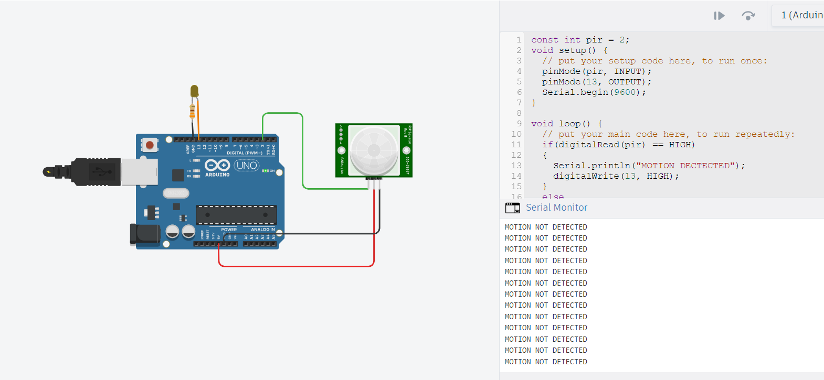

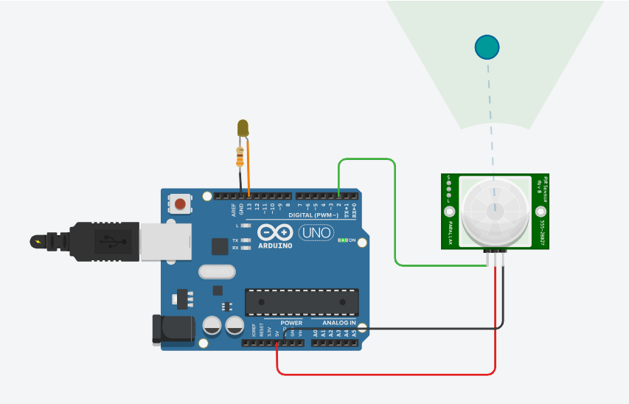

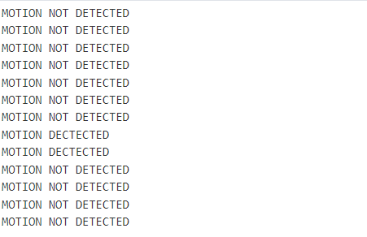

Github Link:

<https://github.com/kevin2-29/Task-M1_T1P.git>